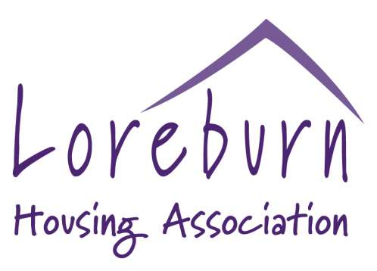

Application for Shared Ownership

For your assistance, this document can also be made available in another language, in Braille, in large print, or on audio cassette.

Please ask any member of staff and the necessary arrangements will be made.

Page | 1

Instructions For Completion

1. Please complete all sections fully. If you require assistance, please ask.
2. Where boxes are provided, tick the box which indicates the response most relevant to you.
3. Where you are asked for more detail and there is not enough room, please use the space on page 8
4. Please refer to the Guidance Notes when completing this Form

Completion of this form does not guarantee approval by the Association for Shared Ownership.

Data Protection Act 2018
Your application will be treated in confidence and in compliance with the Date Protection Act 2018.

SECTION 1

1. Personal Details

 | Applicant | Partner (if applicable)
Preferred Title:
Name:
Address:
Telephone Number: | Work:  Home:  Mobile: | Work:  Home:  Mobile:
Male / Female/Transgender/ Prefer not to say:
Date Of Birth:
Marital Status:

Page | 2

2. Please list everyone currently living at your present address (including yourself)

Name | D.O.B | Relationship to Applicant | Living with you if move? (Tick)
 |  | Applicant

3. Will you require a mortgage? YES / NO

4. If yes, have you approached a Building Society / Bank, concerning availability of mortgage facilities?
YES / NO

5. If yes, are mortgage facilities available to you? YES / NO Please provide name and address below

6. Do you have a Solicitor YES / NO

7. If yes please provide full name and address below

Page | 3

8. Please state the amount of savings you will put towards share purchase

Applicant | £
Joint Applicant | £

9. Please give your total monthly income (after tax and other deductions), including maintenance, family credit, child benefit etc

Applicant | £
Joint Applicant | £

11. How much can you realistically afford to pay for housing (rent + mortgage) per month?

Applicant | £
Joint Applicant | £

SECTION 2

1. Details of your present household
Please indicate which of the following describes your current housing situation (please tick)
 | Applicant | Joint Applicant
Loreburn Housing Association Tenant
Owner-Occupier
Tied Accommodation
Local Council or other Housing Association Tenant
Private Landlord
Living with friends/relatives
Other (please describe)

Page | 4

2. How long have you lived in your current housing situation?

Applicant _____years ______months

Joint Applicant ______years _______months

3. If you are paying rent for your accommodation, please give the name and address of the landlord, agency, or person you are renting from

Name:
Address:

Contact Number:

4. Are you selling your present home? Yes / No

5. If yes please state the approximate value. £

6. Will there be a mortgage left to pay? Yes / No

7. Please state the approximate mortgage left amount: £

8. Has a date of entry been set? Yes / No

9. If yes please state date of proposed entry: Date:

Page | 5

10. Please give the addresses of your previous accommodation in the last five years, starting with your current address (also include joint tenant)

Name | Address | Full Name & Address of Landlord/Mortgage Co. | Date to / from | Reason for leaving

Page | 6

10.Have you ever been a resident in an LHA property before? YES / NO

11.If yes please state address and dates:

Address: Date:

SECTION 3

1. Please state areas and / or towns you are interested in:

1. | 6.
2. | 7.
3. | 8.
4. | 9.
5, | 10.

If you are interested in a particular property or have noted an interest though your Solicitor, please indicate below the property address

Please note that you are required to confirm in writing your intention to purchase a property to the Association.

Page | 7

SECTION 4

1. Employment Details

Job Title:

Applicant | Joint Applicant
Employers Name  Address:  Telephone Number: | Employers Name  Address:  Telephone Number:

2. How long have you been employed in your present job?

Applicant ________years ________months

Joint Applicant ________years _______ months

Page | 8

SECTION 5

1. Please provide any other further information or details why you wish to leave your present accommodation

Section 6

Please read the following points before signing the declaration on page 10

• As a sharing owner you are responsible for all internal and external repairs and maintenance to your property.
• As a sharing owner you have a mutual responsibility for certain items common to you and your neighbours. Any work common to all residents should be organised between you and your neighbours and paid for collectively.
• As a sharing owner you do not have the same rights as tenants in rented properties and therefore the Association does not take on the role a landlord.
• If there any disputes about your rights and responsibilities, you will need to refer to you Occupancy Agreement and Disposition and perhaps seek assistance from your solicitor.
• If you are purchasing 100% or become 100% owner the service charge and shared ownership buildings insurance is still applicable.

Please refer to the Shared Ownership Guidance Notes for more information.

Page | 9

SECTION 7

Declaration

I declare that the particulars given by me on this application form are true in all respects, and I have read Section 6 and agree. I hereby authorise the Association to make any enquiries necessary in connection with my application:

- To any landlord(s) within the last 5 years
- To any Doctor to verify medical circumstances
- To any agency for further details, or to authenticate or to clarify details provided in this application, or associated forms

Where a joint application is being made, both parties must sign

Signed: __________________________

Joint Applicant Signed: _________________________

Date: ____________________________

Date: ___________________________

Please return this application form to:

FREEPOST RSTA-SRCLKHGK,
Loreburn Housing Association
27 Moffat Road
Dumfries
DG1 1NN
Email: customerservice@loreburn.org.uk

Telephone: 01387 321 300

Loreburn Housing Association is a registered Scottish Charity No SC029917

Page | 10

